

Expanding Specialized Stroke Services to Include EVT
Program Expansion Template
February 2019

Expanding Specialized Stroke Services to Include EVT
Overview and Purpose
The purpose of this template is to clearly outline the clinical and business criteria required to expand specialized stroke services to include Endovascular Thrombectomy (EVT). This template should be used by hospitals/LHINs when a request to expand specialized stroke services to include EVT is being made to the Acute and Emergency Services Division of The Ontario Ministry of Health and Long-Term Care (MOHLTC). See Appendix A Process for New/Expanding Cardiac, Stroke and Vascular Program Proposals. Completion of the Readiness Assessment (Appendix B) is recommended prior to completing the Program Expansion Template.
Clinical & Business Criteria- Please provide:

» Criterion 1
Evidence of an existing stroke program within the hospital including:
- A stroke unit that meets the Ontario definition of:
  - A geographical unit with identifiable co-located beds, that are occupied by stroke patients 75% of the time;
  - Dedicated interprofessional team with expertise in stroke care including, at a minimum: nursing, physiotherapy, occupational therapy and speech-language pathology, and
  - Protocols in place that follow current evidence based stroke best practice recommendations for acute stroke management and access to early rehabilitation.
- Capability and experience in the administration of tissue Plasminogen Activator (tPA) as demonstrated by:
  - Median Door to needle times of intravenous thrombolysis of less than 30 minutes with 90% of treated patients with a door to needle time less than 50 minutes, and
  - Standardized care processes for treatment of stroke patients eligible for tPA (e.g. re-printed order sets, patient care pathways, and standard care algorithms).
- Onsite imaging with 24 hour access, seven days a week, including computed tomography (CT) scanner (i.e. 3rd generation or higher helical scanner) with programming for CT angiography (CTA) (multiphase or dynamic). CT technologist onsite 24 hours, 7 days/week. Availability of a biplane angiography suite.
- Neurosurgical support and neurocritical care services (Neuro ICU/Stepdown Unit) available on-site.
- Demonstrated ability to measure, record and report outcomes

Criterion 2
A clear rationale for the development of the stroke EVT program including:
- Substantial evidence for population need, and
- Analysis of available alternatives to meet the identified needs

Criterion 3

Market share analysis to identify the potential impact on referral patterns and volumes of existing Endovascular Stroke Treatment Centres and neighbouring t-PA/telestroke centres in other LHINs within Ontario including:
- Evidence that existing EVT and t-PA centres will be able to retain volumes sufficient to maintain the integrity of their programs despite the redistribution of cases that may occur once the new EVT Centre is performing the minimum volume of cases.

Criterion 4
Evidence of community engagement and/or consultation with clinical experts or other relevant leaders in the health care field including endorsement by:
- Provincial EVT Steering Committee,
- Regional Stroke Steering Committee,
- Hospital administration/senior management team,
- Neurologist and interventional radiologist champion, and
- Local Health Integration Network with confirmation that expansion of specialized stroke services to include EVT is aligned with the LHIN’s critical care services planning and current Integrated Health Services Plan (IHSP).

Criterion 5
Evidence of repatriation agreements to ensure continuity and comprehensiveness of care for patients transferred between hospitals.

Criterion 6
Evidence of a well-developed plan to deliver the recommended minimum case volumes by year two as well as evidence that the new EVT program will have sufficient volumes to maintain clinical competence and be sustainable long term.
Minimum volume recommendations:
- Minimum of 20 cases/year/interventionist

Criterion 7
Demonstrated ability to recruit an appropriate number of interventionists (minimum of 3 is recommended) with required training and experience, to support a 24/7 program including:
- Baseline training and qualifications:
  - Residency training (in radiology, neurology, neurosurgery, vascular intervention) including documented training under the supervision of a board certified neuroradiologist, neurologists or neurosurgeon in the diagnosis and management of acute stroke, interpretation of cerebral arteriography and neuroimaging with subsequent board eligibility or certification.
  - Those physicians who did not receive training during residency noted in the bullet above require an additional period (at least one year) of training in clinical neurosciences and neuroimaging, focusing on the diagnosis and management of acute stroke, interpretation of cerebral arteriography and neuroimaging prior to their fellowship in neuroendovascular interventions.
Post Residency Training
  - Minimum of one year dedicated training in Interventional Neuroradiology under the supervision of a full time neurointerventionist (with neuroradiology, neurology or neurosurgical training background).

Criterion 8
Evidence of a proposed mentor relationship with a designated Stroke Endovascular Therapy Centre who will provide site team support, additional experience as required and ongoing clinical interaction, including clinical and/or administrative consultation for complex cases.

Criterion 9
Evidence of a well-developed plan for ongoing quality assurance including:
- Description of quality assurance program,
- Description of risk management framework,
- Plans for program evaluation, and
- Monitoring system to ensure ongoing quality improvement.

Criterion 10
Identification of the potential barriers that may impact expansion of specialized stroke services to include EVT including:
- Barriers shall be well defined and reflect the extent of program planning,
- Be analyzed in terms of risk to implementation and program growth (example: low risk, moderate risk, high risk), and
- Shall include solutions to mitigate identified barriers.

Criterion 11
Detailed plans of all capital requirements including cost of:
- Renovations,
- Expansion,
- Equipment,
- Information technology investments,
- Decanting/moving costs, and
- Ancillary costs as defined in the Capital Planning Manual.

»

Criterion 12
Detailed budget including:
- One-time start-up costs
- Training costs, and
- Ongoing operational (base) costs

»

Criterion 13
Proposed implementation timelines including:
- High-level activities (milestones),
- Anticipated timelines in months (example: first activity starting at date “zero” and the last activity and timeline when the proposed service is operational. Regarding operational timeline please include the integration into regional/provincial protocols as part of the system implementation), and
- A well-developed plan to implement Endovascular Thrombectomy 24/7.

»

Appendix A
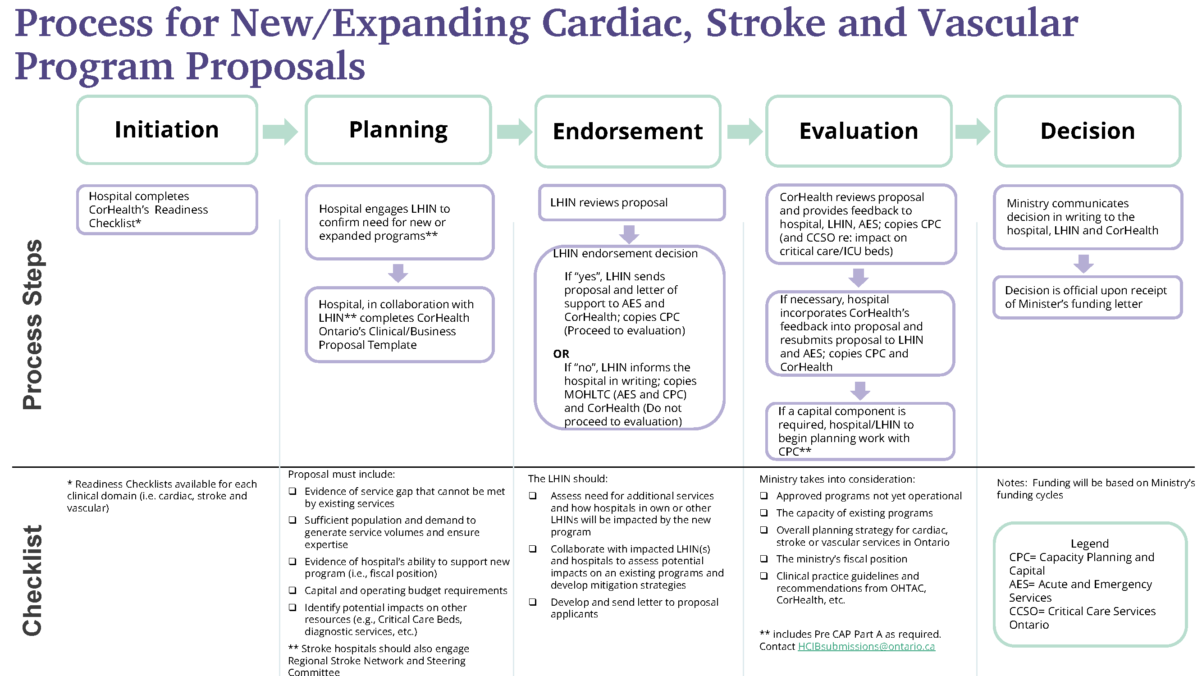

Appendix B

Stroke EVT Program Readiness Assessment

Purpose
The CorHealth Stroke Endovascular Thrombectomy (EVT) Program Readiness Assessment provides organizations, who may be interested in expanding their current stroke program to include endovascular thrombectomy, with a list of conditions that should be in place prior to proceeding with the more detailed business proposal template as the next step in the expansion planning process (Appendix A).

Instructions:
Review each critical element and indicate your organization’s level of readiness.
Level of Readiness | Definition
Ready | Critical element has been achieved and supporting documentation exists
In Progress | An action plan has been developed to achieve critical element
Not Ready | Critical element is not in place and no plan has been developed to achieve

Sites that answer “Yes” and/or “In Progress” may consider pursuing the more detailed business proposal. Opportunities to provide rationale, action plan and/or supporting documentation can be found in the detailed business proposal.
Sites that answer “No” to any of the critical elements should re-evaluate their readiness to pursue program expansion.

Readiness Checklist
Medical and Administrative Leadership
Critical Element | Yes | In Progress | No
Has the idea to expand services received support from medical and administrative site leaders?
Do you have a neurologist who will champion this change?
Do you have an interventional radiologist lead who will champion this change?

System Level Engagement
Critical Element | Yes | In Progress | No
Has your regional stroke network been engaged?
Have you involved other regional stroke networks that may be impacted by the expansion?

Infrastructure
Critical Element | Yes | In Progress | No
Does your site have a stroke unit that meets the Ontario definition?
Does your site have neurocritical care services to provide post procedure care?
Do you have imaging on site with 24 hour access, seven days a week, including CT scanner (i.e. 3rd generation or higher helical scanner) with programing for CTA (multiphase or dynamic)
Treatment Experience/Expertise
Critical Element | Yes | In Progress | No
Is your site currently offering thrombolytic therapy to suitable ischemic stroke patients?
If administering tPA, are target door to needle times being achieved (target of less than 30 minutes with a median time of less than 50 minutes)
Does your site have a core stroke team with stroke expertise (i.e. neurologist, nursing, occupational therapy, physiotherapy, speech language pathology, social work, etc.)?

Site approval does not assume MOHLTC funding. Funding will be based on Ministry’s funding cycles.
“A geographical unit with identifiable co-located beds (e.g. 5A -7, 5A-8, 5A-9, 5A-10, 5A-11) that are occupied by stroke patients 75% of the time and has a dedicated interprofessional team with expertise in stroke care with the following professionals at a minimum nursing, physiotherapy, occupational therapy, speech language pathologist” (Health Quality Ontario, 2016, p. 48)
For post procedure care: Able to admit to a designated critical care/Step down and/or Stroke Unit with monitoring capabilities and protocols in place that follow current evidence based-stroke best practice recommendations5”

