Read Me
The purpose of the business case is to clearly outline the objectives and strategic alignment of the proposed initiative with an organization’s vision and goals, in order to justify expenditures (budget, people, and time) and seek sponsorship and approval to proceed. The document should identify the objectives, scope, and anticipated outcomes of the proposed work.
The following is a template for creating your business case. Some standard information has already been pre-populated for you – you do not have to use this information, and can revise the entire document as you wish. [Bracketed information] is for guidance only and should be removed from your finalized document. You can update the table of contents by clicking on it and selecting “Update Table” and then “Update Entire Table”. Remove this “Read Me” section from your final document.
For assistance with creating your business case, you may contact the CorHealth Ontario heart failure team at service@corhealthontario.ca.

Business Case

Integrating Heart Failure Care in [Enter name of region]

[Enter name of person/organization preparing this business case]

[Enter Date]

Table of Contents
Executive Summary 3
Background 4
Heart Failure in the Local Context 5
Comments from Patients, Caregivers, and Providers 5
Current State 5
Proposal of Initiative 6
Outcomes 6
Challenges and Opportunities 7
Required Resources and Support 7
Appendices 8

Executive Summary
[The Executive Summary is a succinct overview of the entire business case. It provides the reader with a quick glance of what you are proposing, what you believe it will accomplish for heart failure care, for the organization, for the patients and caregivers, and what resources are required to do the work. The Executive Summary should be no more than one page.]

This business case has been prepared on behalf of [insert names, department, or organization], with the intent of implementing an integrated approach to providing quality heart failure care in [enter your geographic area of interest/targeted Ontario Health Team/etc.].
The current and evolving demands associated with a chronic, complex condition like HF, and the challenges in meeting these demands, requires a collaborative and connected partnership approach at the local level (among primary care physicians, specialists, and allied health professionals). CorHealth Ontario’s ‘Spoke-Hub-Node’ model of integrated HF care and the Health Quality Ontario’s Quality Standard for adult heart failure care in the community are two sets of evidence-based heart failure standards which form the basis of this proposed initiative.
[Enter a short paragraph here about why heart failure should be integrated in your local context. What are the gaps and challenges currently? How could integrated heart failure care help? What is the local burden of heart failure (high level)?]
An integrated approach to heart failure care delivery in our local context will lead to several positive benefits including, [enter comments here that align the proposed initiative with the organizational vision/mandate or strategic directions].

Background
[This section has been pre-populated for you with some basic information about heart failure to provide the reader some context. Revise as needed.]

HF is a complex and chronic condition where the heart is no longer able to meet the metabolic demands of the body. The most common symptoms of HF include shortness of breath, fatigue, and leg swelling. The incidence and prevalence of HF increases with age and people with HF tend to be frail and have multiple comorbidities. Even with advancements in treatment, HF continues to be a progressive and ultimately fatal condition – 50% of people with HF will not be alive within 5 years of diagnosis. Patients living with HF experience periods of stability interrupted by periods of worsening symptoms and instability, often leading to hospitalization (Figure 1).
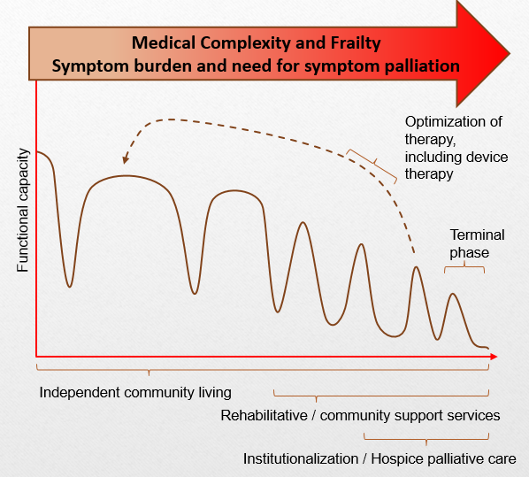
Figure 1. The trajectory of heart failure illness progression

Heart Failure in the Local Context
[Enter anecdotal and statistical information here to highlight the burden of heart failure in your local context. How are patients and caregivers affected? How are healthcare providers affected? What is the quality of heart failure care like? For heart failure data by specific region, refer to the HQO website for the Heart Failure Quality Standard Data Table – click here.]

Comments from Patients, Caregivers, and Providers
[If you have any comments from patients and caregivers, or providers, enter them here. These comments will compliment your proposed initiative and help strengthen your business case.]

Current State
[Enter what is currently being done around heart failure care in your region (services, programs, etc. Refer to the Environmental Scanning section of the Toolkit). Highlight what is missing, what is the opportunity for improvement, what is the need, and why it exists. Describe the existing capacity (financial and human resources) to take on this work]
For example: Currently, in the (enter region name) region, there is a lack of coordination and integration across providers of heart failure care. Across primary care providers, internists/hospitalists, and acute care and community heart failure specialists in the region, there is an opportunity for improvement in terms of [communication, coordination of services, education, etc].

Proposal of Initiative
[Enter what it is you are proposing to do. What are you trying to achieve, and what it looks like. This should include what is ‘in scope’ and what is ‘out of scope’. Describe the strategic alignment of the initiative/project with the organization/region/Ontario Health Team). What is driving this work? (provincial objectives, other complementary efforts going on, improving patient care, how will it benefit the organization)]

Outcomes
[Enter the expected result or benefit that the organization/region/Ontario Health Team is striving to achieve as a result of this work. You may want to include the number of patients your proposed initiative will impact, how it will impact patient and caregiver experience, and health system outcomes (i.e. keeping patients out of hospital, etc).]

Challenges and Opportunities
[Enter some challenges/risks that may impact the success of the proposed work, as well as any opportunities that could strengthen the proposed work. What could be done in response to these challenges and opportunities. This section demonstrates that you have thoroughly considered many aspects of the project/initiative.]

Required Resources and Support
[Outline the resources, dependencies, and/or time requirements to move forward with this proposal. This may include project coordination support, equipment, travel costs, access to meeting rooms, access to a teleconferencing line, or web-based document sharing platform, reimbursement for meeting costs (coffee, tea, etc). Consider your specific environment and context to populate this section appropriately – ‘Is what I am asking for reasonable?’]

Appendices
[Include any appendices here – this may include stakeholder lists, data tables, diagrams, maps, etc.]

Ezekowitz J. A., O’Meara E., McDonald M. A., Abrams H., Chan M., et al. (2017). 2017 Comprehensive Update of the Canadian Cardiovascular Society Guidelines for the Management of Heart Failure. Canadian Journal of Cardiology, 33, 1342-1433
Blais C., Dai S., Waters C., et al. Assessing the burden of hospitalized and community-care heart failure in Canada. Canadian Journal of Cardiology, 30, 352-358.
Foebel A. D., Hirdes J. P., Heckman G. A., et al. A profile of older community-dwelling home care clients with heart failure in Ontario. Chronic Disease in Canada, 31(2), 49-57.
Roger V. L. (2013). Epidemiology of heart failure. Circ Res 113(6), 646-659.

